**4. EKS Fargate - Deploy to Fargate & Test & Clean-Up**

--- Reference - <https://github.com/stacksimplify/aws-eks-kubernetes-masterclass/tree/master/09-EKS-Workloads-on-Fargate/09-01-Fargate-Profile-Basic>

**Deploy Workload to Fargate**

**# Deploy**

--- **kubectl apply -f kube-manifests/**

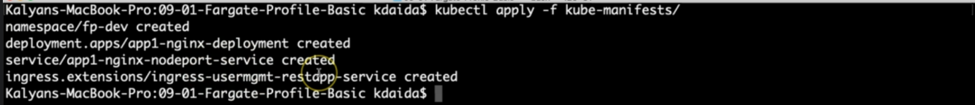

**# List Namespaces**

--- **kubectl get ns**

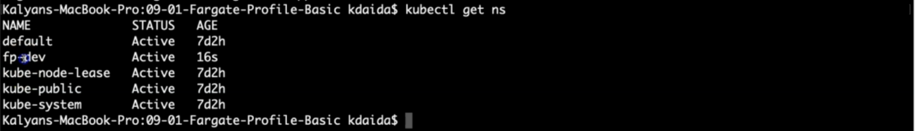

**# List Pods from fpdev namespace**

--- **kubectl get pods -n fp-dev -o wide**

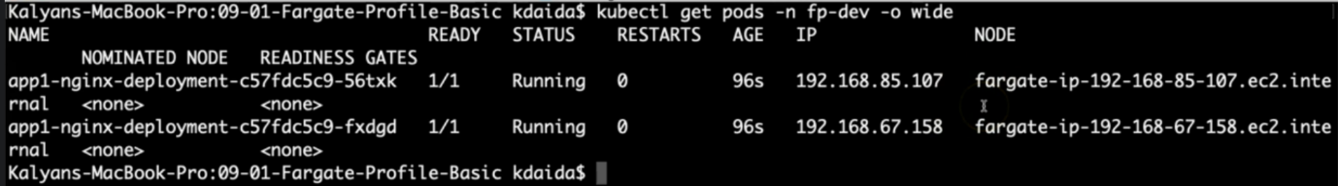

**# List Worker Nodes**

--- **kubectl get nodes -o wide**

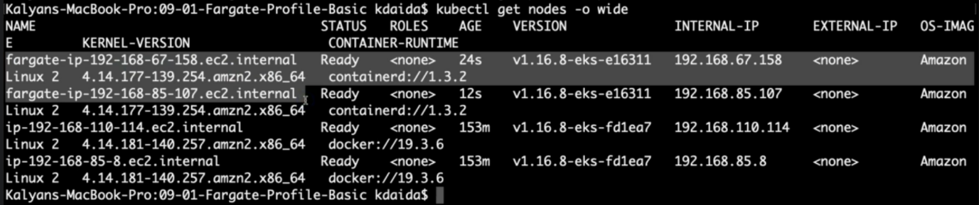

--- **note** – the fargate node starts with fargate-ip…etc. 2 fargate nodes got created because we set 2 replicas in the deployment manifest.

**# List Ingress**

--- **kubectl get ingress -n fp-dev**



--- **note** - application load balancer is created and under address, you will find the load balancer end point.

--- got aws -> EC2 -> load balancer.

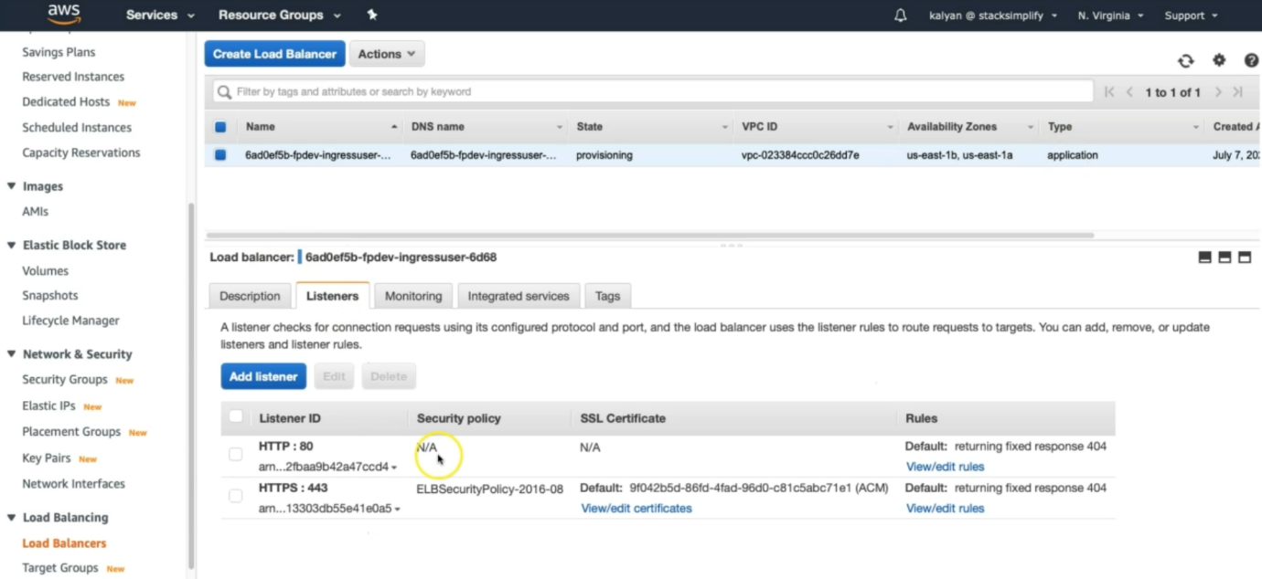

--- **note** – application type load balancer is created and click on HTTP: 80 view/edit rules.

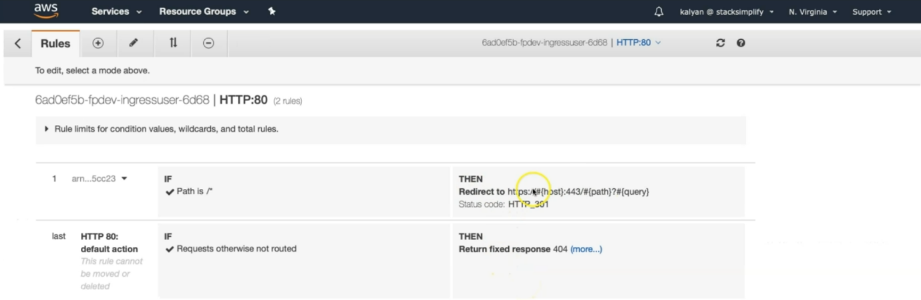

--- the redirection thing is there. From http to https and go to HTTPS: 443 view/edit rules.

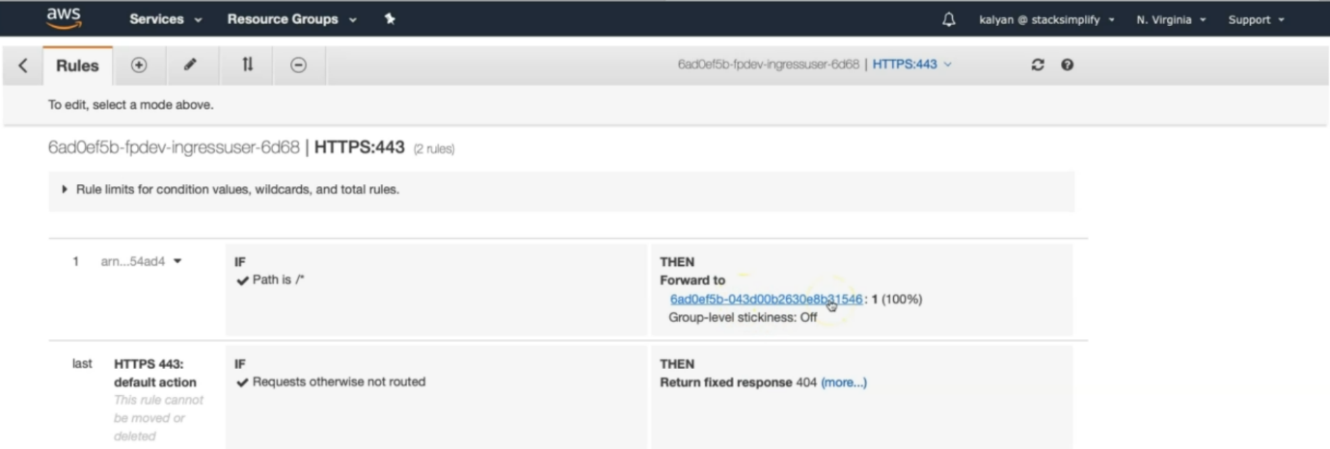

--- here, the path is /*, because we defined it in ingress service manifest. We defined /*, because, this is for single application. Everything will go to one target group.

--- go to the target group

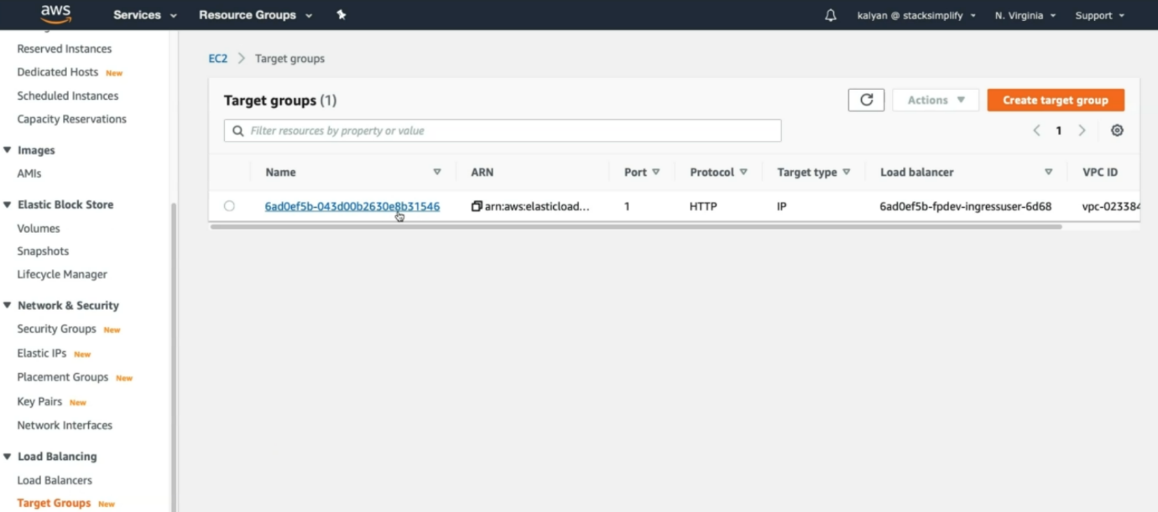

--- **note** - click on target group. You can see above; the target type is ip not instance.

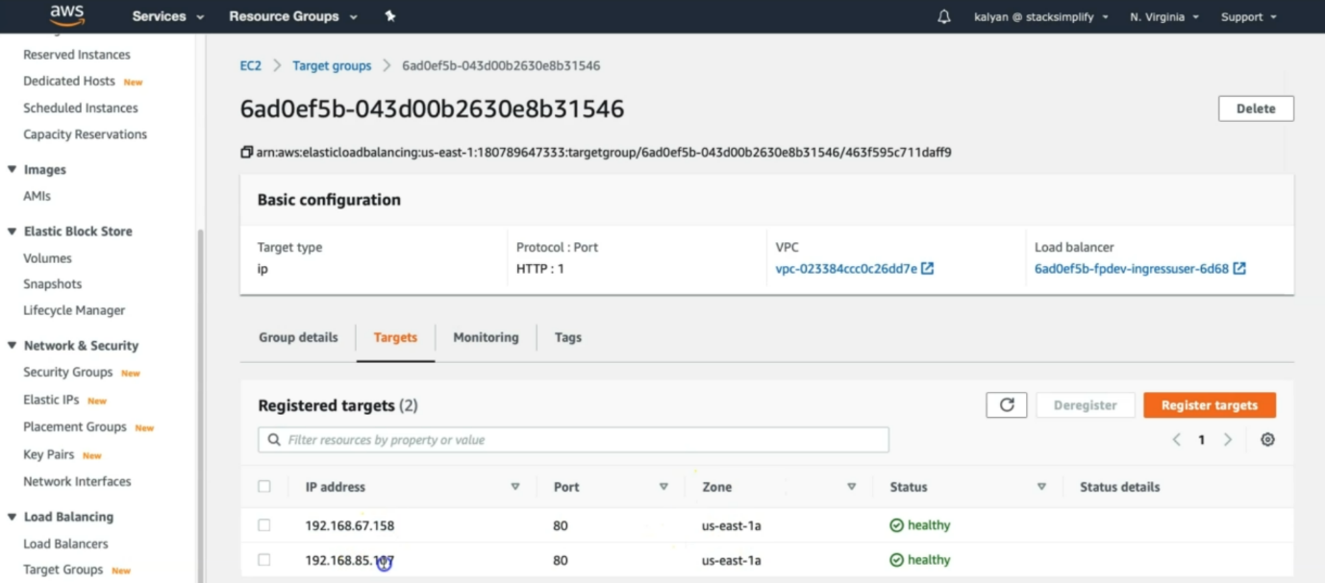

--- **kubectl get pods -n fp-dev -o wide**



--- **note** – our pod IP and our node ip are same.

**Access Application & Test**

**# Access Application**

--- <http://fpdev.kubeoncloud.com/app1/index.html>

**Delete Fargate Profile**

**# Get list of Fargate Profiles in a cluster**

--- **eksctl get fargateprofile --cluster eksdemo1**

**# Delete Fargate Profile**

--- **eksctl delete fargateprofile --cluster <cluster-name> --name <Fargate-Profile-Name> --wait**

--- **eksctl delete fargateprofile --cluster eksdemo1 --name fp-demo --wait**

**Verify NGINX App1 got scheduled on Managed Node Group**

--- After fargate profile deletions, apps running on fargate will be scheduled on Node Groups if they exist if not will go to pending state

**# List Pods from fpdev namespace**

--- **kubectl get pods -n fp-dev -o wide**

**Clean-up**

**# Delete**

--- **kubectl delete -f kube-manifests/**

**References**

--- <https://eksctl.io/usage/fargate-support/>

--- <https://docs.aws.amazon.com/eks/latest/userguide/fargate.html>

--- <https://kubernetes-sigs.github.io/aws-alb-ingress-controller/guide/ingress/annotation/#annotations>

--- <https://kubernetes-sigs.github.io/aws-alb-ingress-controller/guide/ingress/annotation/#traffic-routing>

---